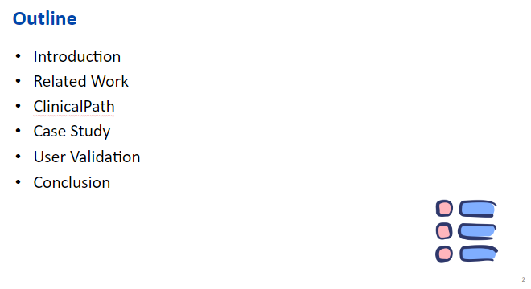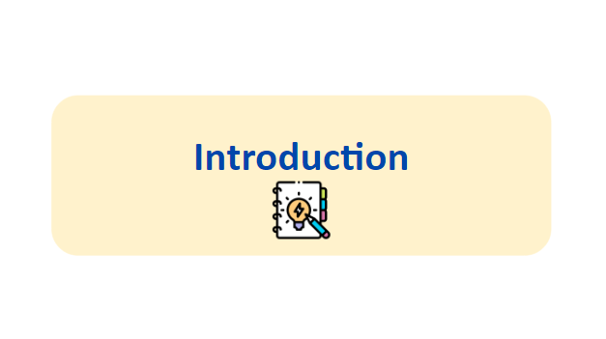
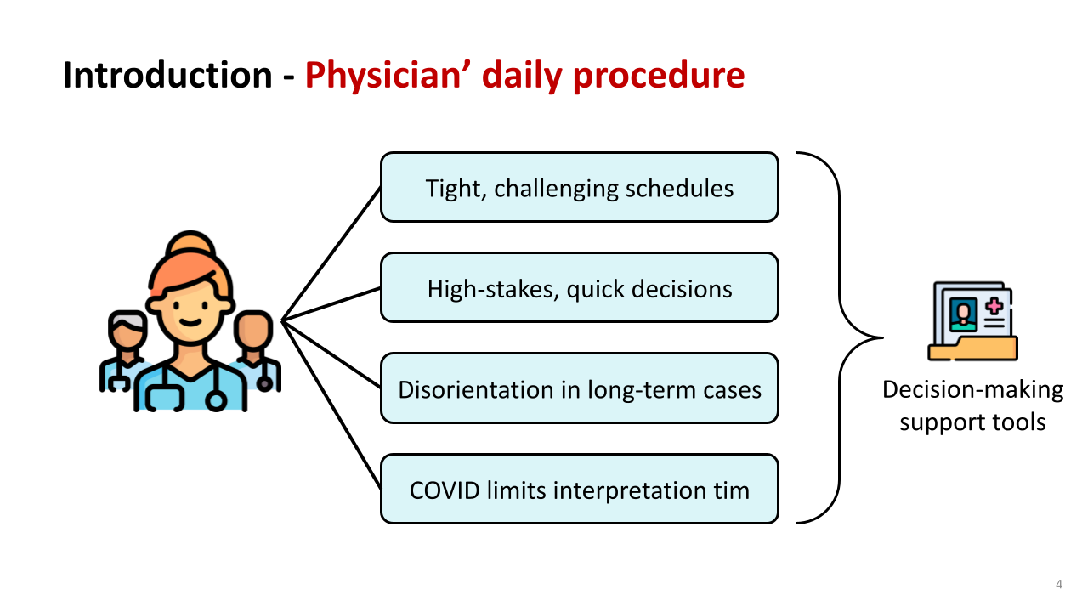 | Doctors work on a very tight schedule because they are often making difficult and important decisions regarding a patient’s condition that must quickly and precisely. In the case of a long-term illness, they must examine and compare large amounts of data so they can be tired, creating misleading impressions. As we know, the COVID-19 pandemic leads experts to work long shifts, so they have less time for patient test history interpretations. So, they need decision-making support tools to help improve their work in a timely and reliable manner.
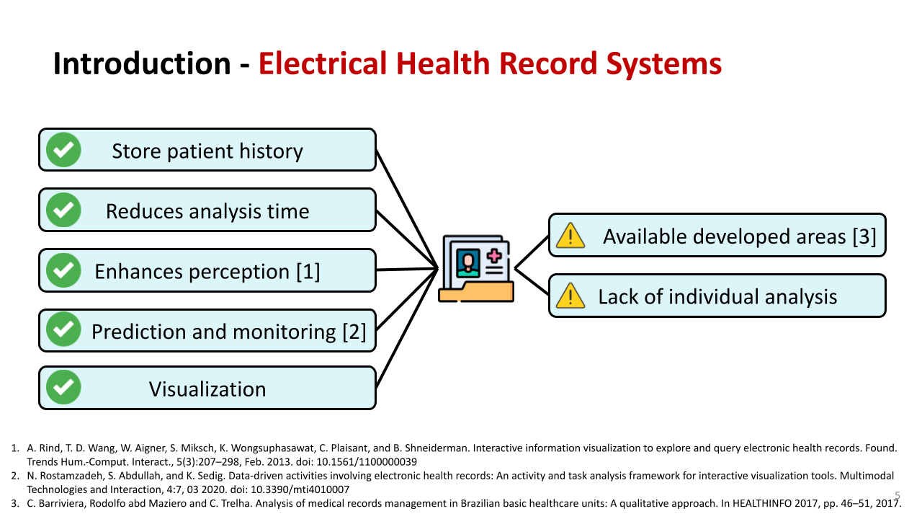 | EHR systems store the patient's clinical history, support clinical decisions, and reduce the time spent analyzing the patient’s data. It helps to enhance diagnostic accuracy and support the tasks of explaining, predicting, monitoring. But recent studies show that EHR is being used in countries where in capital and better-developed areas. Additionally, general findings involving tests and patients rather than local analysis of diagnostic hypotheses for each patient However, doctors still need the better tools to support decision-making.
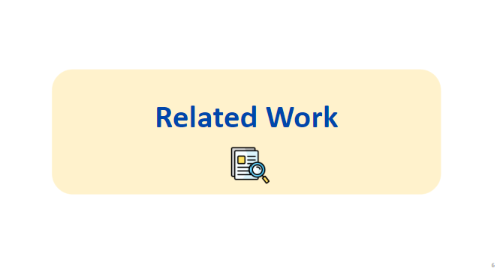
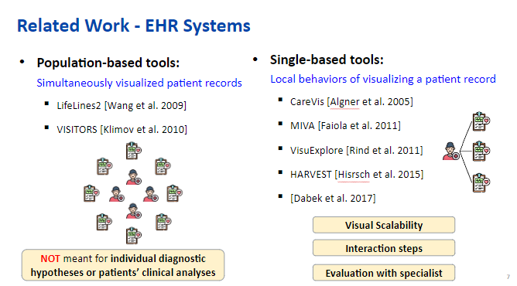 | We focus on two types of EHR systems: population-based and single-patient tools.  Population-based tools focus on general behaviors of visualized patient records at the same time. It is the most popular, but they usually focus on general tasks, such as insights considering a set of patients to find similarities or trends in test results. Therefore, these tools are not used for individual diagnostic hypotheses or patients’ clinical analyses.  Single-patient tools focus on local behaviors of visualizing a patient record, It allow to compare the test results and understand their variation over time.  Although existing studies also focused on EHR systems, they concentrated on global and general findings involving tests and patients rather than local analysis of diagnostic hypotheses for each patient.
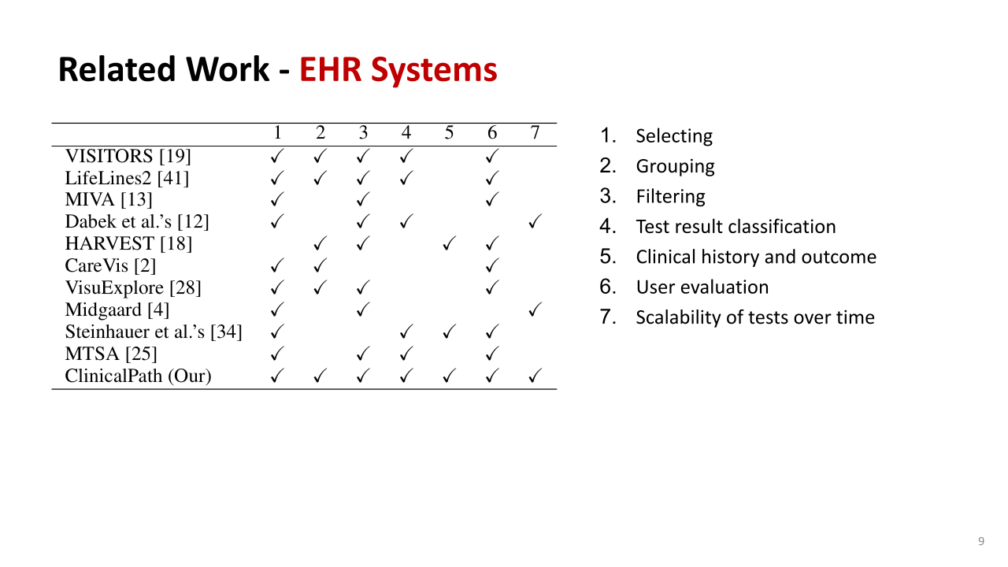 | This slide compares EHR systems based on seven functions: selecting, grouping, filtering, test result classification, clinical history tracking, user evaluation, and scalability. ClinicalPath system covers all these features.
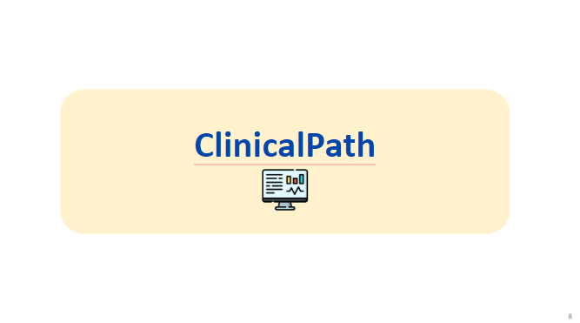
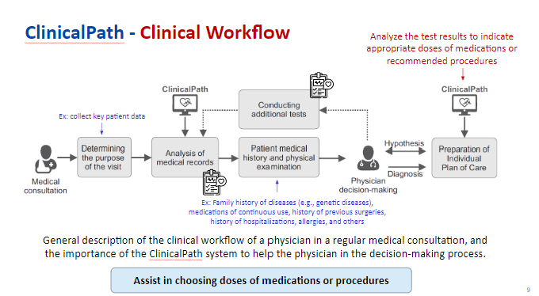 |  | This figure shows a clinical workflow as the steps of the doctor in a medical consultation.  In the first step, the doctor collects key patient data, such as age, gender, profession, patient address, and weight, and understands the purpose of the visit.  After that, the doctor will consult in the ClinicalPath system to check the previous medical records of the patient to match the described conditions.  Then, the doctor performs a physical examination and checks the patient's medical history, such as the family history of diseases, medications of continuous use, history of previous surgeries, hospitalisations, and others.  In the decision-making phase, the doctor can create a hypothesis that can be an urgent care plan to reduce instant problems and perform additional tests to confirm or remove the hypothesis.  If the doctor has enough information, including the diagnosis and treatment, the patient’s problem will begin to treat.  When the patient returns in the future, the doctor can execute the clinical workflow again to verify whether the treatment was successful.  Especially, ClinicalPath also plays an important role in helping the doctor analyze the test results to suggest appropriate doses of medications or recommended procedures.
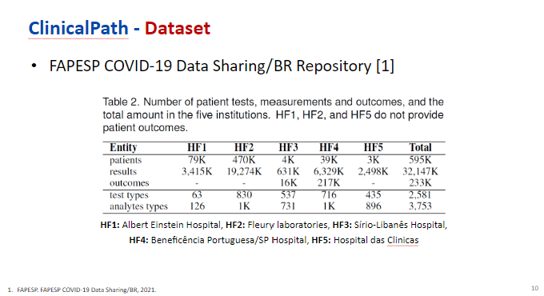 |  | We use the COVID-19 Dataset which is composed of data from 5 major healthcare institutions in Brazil.  This table shows the number of each type of entity such as clinical tests, outcome, and demographic information from the 5 institutions.
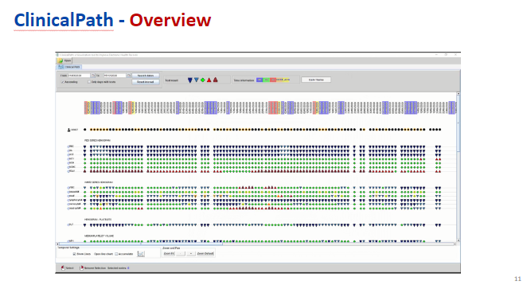 |  | - Next, I will introduce the functionalities of this system in detail.  - ClinicalPath is a freely available system developed in Java to support multiple platforms. It requires the data displayed in a graph format.
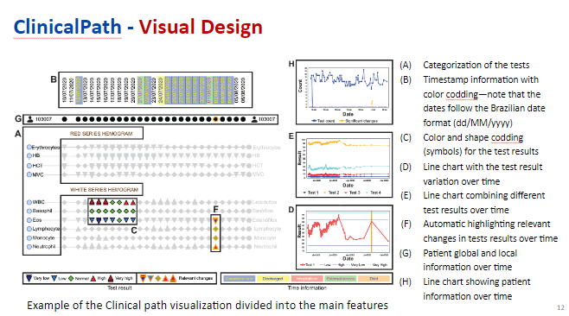 |  | - This figure shows the main features of ClinicalPath. The clinical system is mainly divided into 8 sections.  - It is visualized separately for each patient, following the structure of single-patient tools.
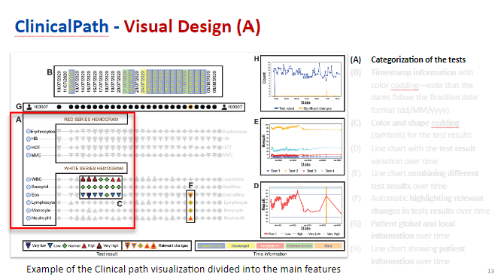 |  | - Section A shows the groups of tests.  - We have different categories for each dot here where there is a list of tests. For example, red series hemogram have HB value, HCT value, and so on.  - The first categories are the most common tests, and the order inside each group may have clinical meaning, approximating tests often analyzed together. However, this order may change depending on the context.
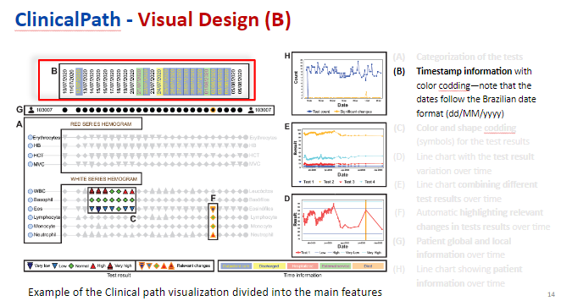 |  | - Section B highlights the clinical history by timestamp.  - The color of the rectangle timestamp shows the patient result in the hospital.  - As you can see on the bottom right, there are five color information which indicates the status in hospital such as outpatient care, discharged, hospitalized, external service, and died.
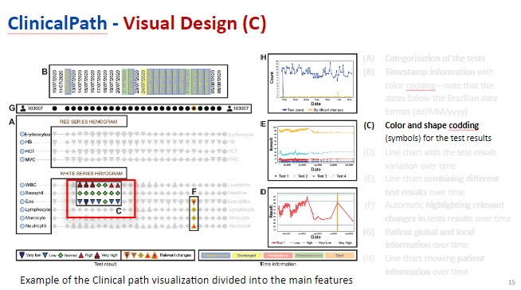 |  | - Section C shows the test results in different timestamps according to different colors and shapes.  - The test result is divided into 5 symbols with different colors in temperature-based visualizations. It helps to reduce the screen space effectively. Moreover, representing the same information in two visual channels (color and shape), in order to avoid color blindness issues.

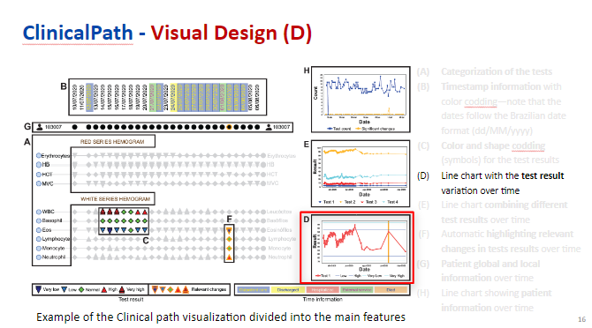 | - Section D shows a line chart that is accessed by double-clicking on the test’s name in Section A. Each line chart is opened in a different window, users can be manually positioned to compare different tests easily.  - For example, the red line shows the results of a specific test varying over time. The dark blue lines show the low and high reference values and the light blue lines indicates the very low and very high values. It helps to understand the test results, highlighting whether the results are above or below the defined value.  - Besides, the orange vertical lines show timestamps with a high variation of test results.
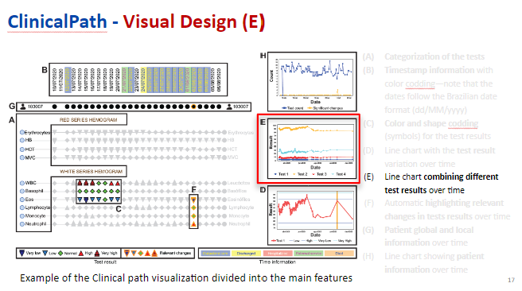 | - In Section E, users can select multiple tests and open them in a single window.  - The lines show reference values and timestamps with high variation. Different tests are associated with different colors and symbols along their lines.
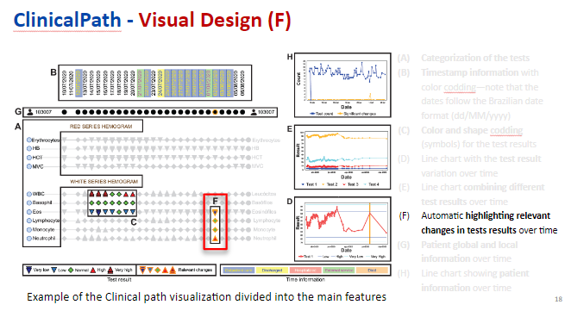 | - Section F indicates a visual approach to automatically highlight relevant changes in test results over time by using strong orange borders applied to the symbols defined in Section C.  - In this way, it can improve guidance by adding a hint to draw user’s attention into meaningful variations in the test results.
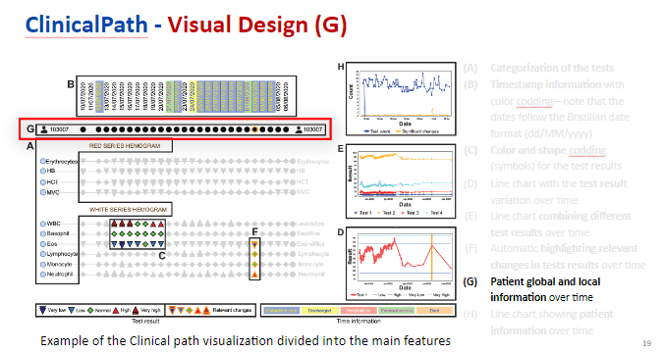 | - Section G shows patient information, which contains global and local information over time.  - The black circles appearing in timestamps display there was at least one test. Moreover, like section F, it can also be highlighted with orange borders in timestamps where there are test results with relevant changes.
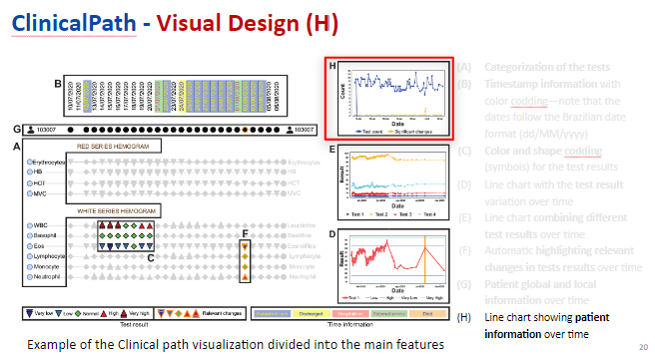 | - Last, Section H shows a line chart summarizing the number of tests and relevant changes over time.  - All of these functionalities help users to find relevant timestamps of interest.
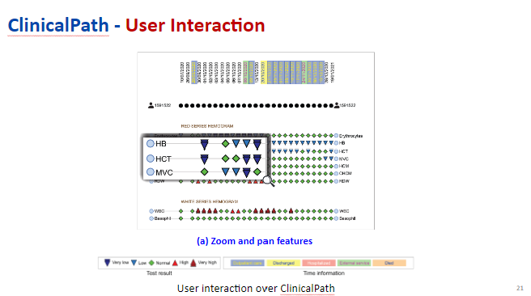 | - After introducing the main idea of visual design, I will show the more details with the part of user interaction.  - In this system, it proposes several interactive tools to improve the user experience and facilitate navigation and decision-making processes.  - In Fig a, the system allows zooming and panning to facilitate navigation and exploration.
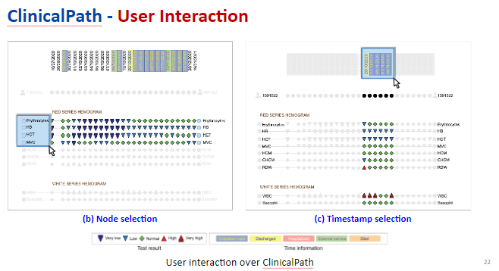 | - Secondly, users can click on specific tests or draw a selection area to highlight the interested regions and focus on what is the current target.  - For example, users can select parts of nodes they want to focus on by drawing this area.
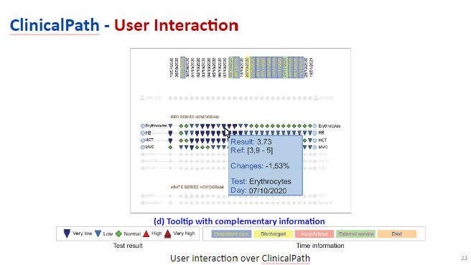 | - Thirdly, when users hover the mouse over the corresponding symbol, this system provides extra information about a test result of interest such as test information, result, and how much the values changed comparing to the left timestamp.
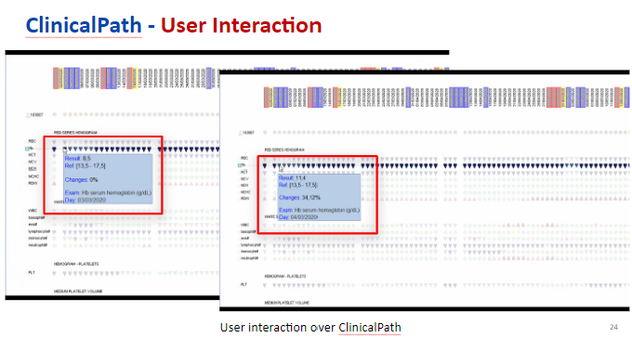 | - For example, in the first day, we have the result of 8.5. In the next day, the value becomes 11.4, which increases 34% comparing to the first day, and the symbol turns the dark blue into the light blue, from very low value to low value.
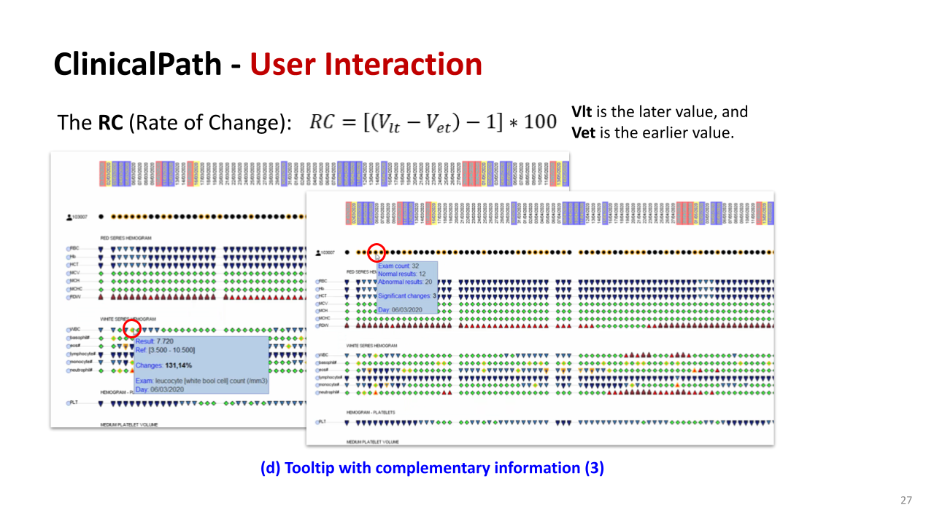 | - In addition, this system adds orange borders in the symbols when the change is over 100%, which shows there is a high variation of test result.  - The Rate of Change formula calculates percentage shifts between test values, flagging changes over 100% with visual cues. This tool helps clinicians detect critical fluctuations, enhancing patient monitoring and supporting timely, informed decisions.
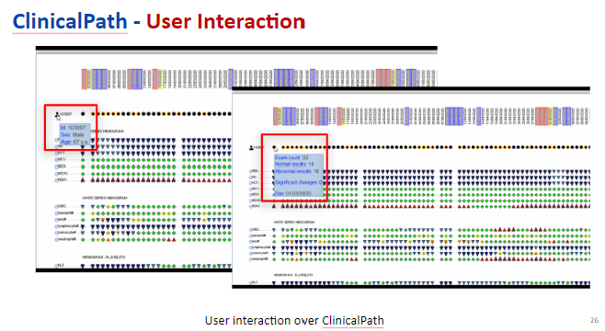 | - Besides, we can also hover the mouse on the patient ID or the dot of patient information, and it can show the patient data and general information of each day like the figures.
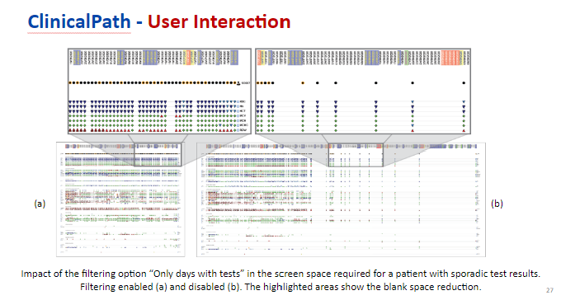 | - Last, this system offers a filtering option to show only days for which there was at least one test result.  - In other words, this filter is essential to hide the days with no activity, like the right figure, which improves the visualization by approximating tests’ results horizontally, and reduces the needed screen space.  - It is useful when analyzing patients that performed tests occasionally.

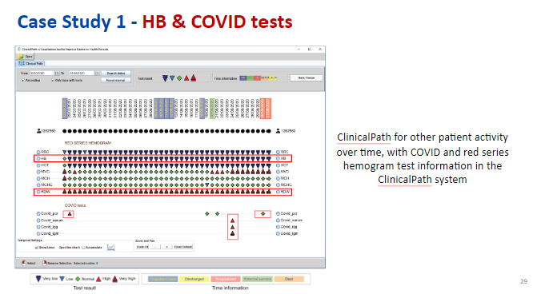 | In the first case study, it focuses on red series hemogram and COVID tests. In this figure, we can see that several tests on different days presented abnormal results.  For example, Hemoglobin (HB) value was shown very low for a lot of days. Red Cell Distribution Width (RDW) presented very high values correlated to the red series results.  Besides, The result of COVID test, we can see that the first test of PCR showed an abnormal results, which meant that the patient was infected with COVID.  After about three weeks, the PCR value was back to normal, it mean that the patient had recovered from COVID.  But the other three indexes for COVID test are abnormal. It mean shows that the patient had the disease before, also logical with the previous PCR test.  From this system, we can observe the relation between COVID and the red series hemogram.  That means we can see how the COVID infection affects the values of red series hemogram, like more serious anemia.
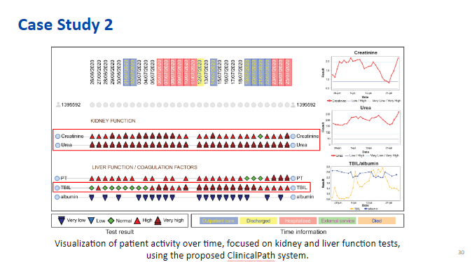 | In the second case study, it shows the tests for kidney function and liver function (creatinine, urea, prothrombin time (PT), total bilirubin (TBIL), and albumin) using symbols and a line chart showing the variation over time. It highlights the patient clinical evolution at each timestamp.  With the red triangle in kidney function, This patient had very high values of creatinine and urea tests over several consecutive days. It means the patient had serious kidney disease. Besides, from the time information, we can see that this patient admit the hospital when the value of TBIL turned normal to very high, which shows the liver was also not functioning correctly.  A worsening condition leads to rehospitalization for albumin replacement. This case highlights how ClinicalPath allows quick identification of critical test results in complex conditions, assisting in ongoing care decisions.
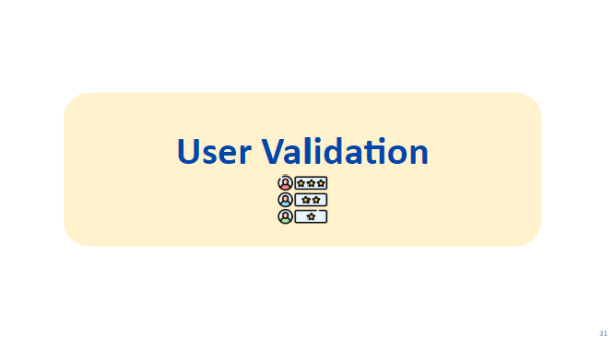
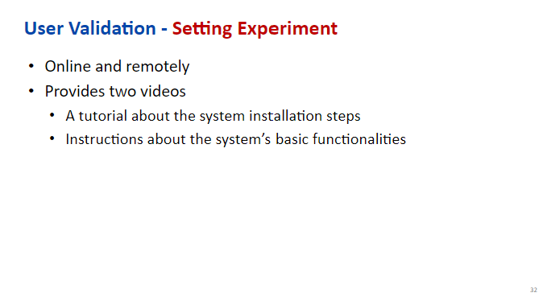 | We evaluated both online and remotely. We provided each participant with two videos. One is a tutorial about the system installation steps, and the other contains instructions about the system’s basic functionalities.
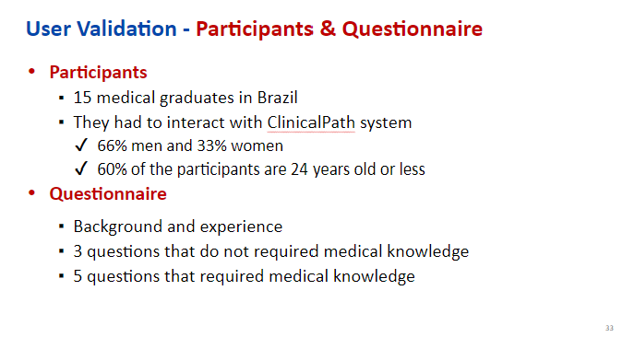 | We have 15 participants, all medical graduates from Brazil. 60% of the participants are 24 years old or less. The questions were divided into (i) background and experience; (ii) 3 basic questions that do not require medical knowledge from the participants; (iii) 5 advanced questions that require medical knowledge to be answered.
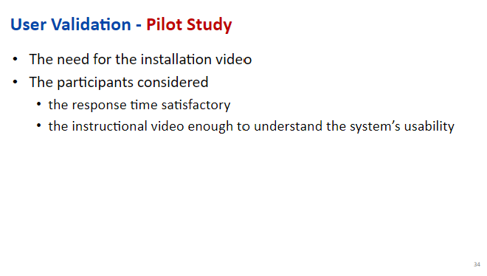 | The pilot evaluation was conducted with two participants. From the feedback, they realized the need for the installation video. The participants considered the response time reasonable and the instructional video enough to understand the system’s usability.
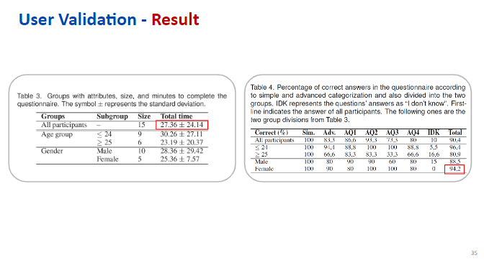 | Table 3, According to the participants' self-described characteristics, we assessed the analysis based on the following two participant characteristics. Then, we separated each group into subgroups with various characteristics. The total time to execute the experiment was similar to the average time for all participants, except for the female subgroup. The older and the females are the fastest to complete the experiment.  Table 4 presents the proportion of correct answers for the multiple-choice questions. The results were divided into simple and advanced questions. The accuracy of the simple questions was 100%. The answers of all participants achieved more than 90% with both simple and advanced questions. The participants that achieved the best results were females and those less than 24 yrs old. The older group had the worst result and the answer “I don’t know” is the highest.
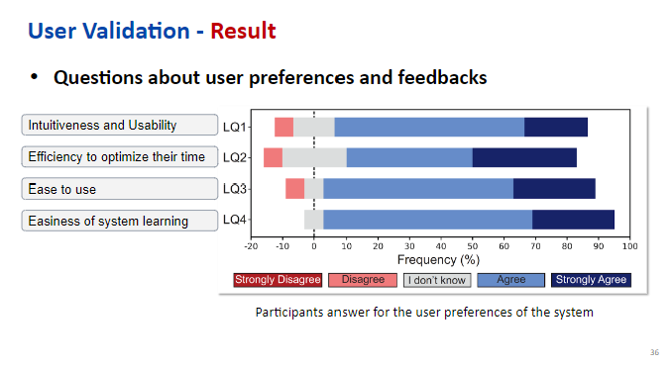 | This is the result of participants’ preferences about the system. They divided the choices into 4 questions with respect to the interface intuitiveness and usability, the efficiency of the system to optimize their analysis time, ease to use, and system learning easiness. They achieved more than 80% of positive answers for the intuitiveness and usability of their system. With the disagreed answers, participants also suggest the improvements like using a familiarized textual medical record system and integrating the system to improve efficiency.
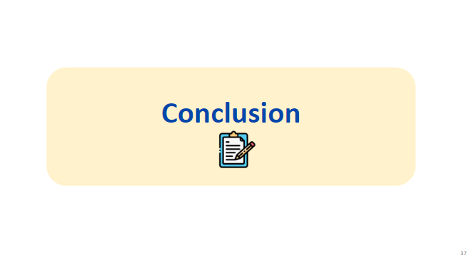
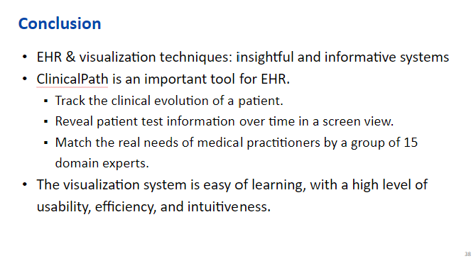 | Information visualization plays an important role in the understanding and interpretation of data. In this paper, they proposed and evaluated an important tool for EHR called ClinicalPath. It allows users to track the clinical evolution of a patient, and provide the test information over time in just a screen view. Especially, their system was developed in collaboration with domain experts to ensure that the technical aspects effectively match the real needs of doctors. They conduct a case study and evaluated with a group of 15 domain experts. They achieved the evaluated result that the system is easy of learning, with a high level of usability, efficiency, and intuitiveness.
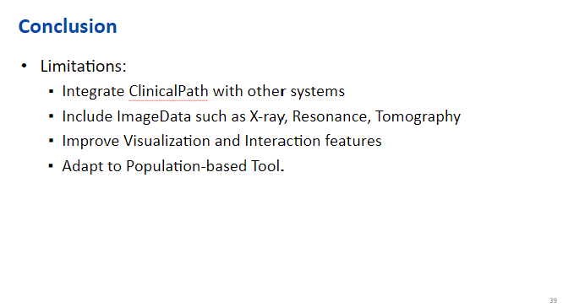 | ClinicalPath is an intuitive and important tool for physicians to perform decision-making tasks. However, there are limitations in both the data set and the system that require further improvements. The system should integrate with other systems, include ImageDate like X-ray, Improve Visualization and Interaction features and adapt to population-based tool.

